Customer Financial Behavior Dashboard
Screenshot :
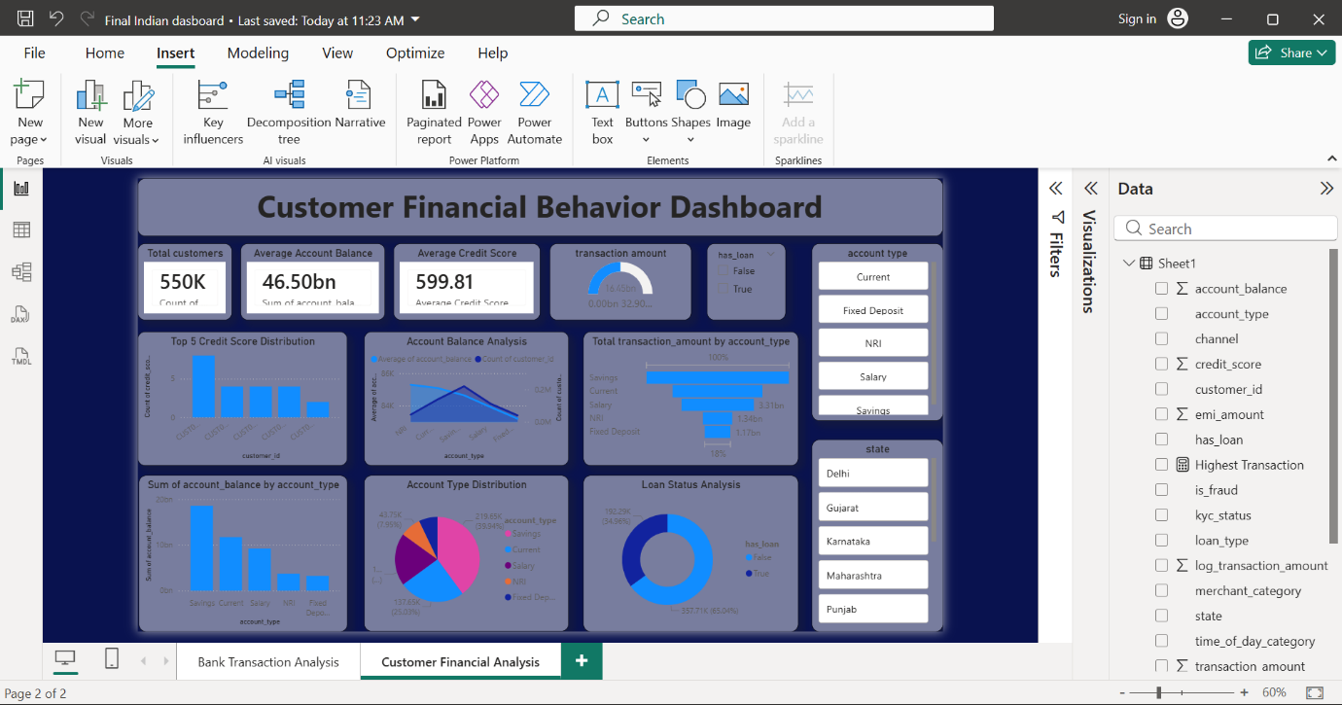
The Customer Financial Behavior Dashboard is designed to analyze customer financial activity, spending behavior, account performance, and banking engagement using Power BI visualizations.
The dashboard helps banks understand how customers manage their accounts, perform transactions, maintain balances, and use financial services.

1. KPI Cards
The KPI cards display important customer financial metrics such as:
- Total Customers → Total number of banking customers.
- Average Account Balance → Average balance maintained by customers.
- Average Credit Score → Overall customer credit performance.
- Average Transaction Amount → Average value of customer transactions.
- Customers with Loan → Number of customers having loans.
These KPIs provide a quick summary of customer financial behavior.

2. Credit Score Distribution
This chart shows the distribution of customer credit scores.
Insight:
Most customers maintain moderate to good credit scores, indicating stable financial conditions and responsible banking behavior.

3. Credit Score vs Transaction Amount
The scatter plot compares customer credit score with transaction amount.
Insight:
Customers with higher credit scores often perform larger transactions and maintain stronger financial activity.

4. Account Balance Analysis
This chart compares balances across account types such as:
- Savings
- Current
- Salary
- NRI
- Fixed Deposit
Insight:
Savings accounts usually maintain higher balances and are widely used by customers.

5. Account Type Distribution
The pie chart shows the percentage of customers using different account types.
Insight:
Savings accounts are the most preferred account type among customers.

6. Loan Status Analysis
This chart displays customers with and without loans.
Insight:
It helps understand customer borrowing behavior and financial commitments.

7. Customer Segmentation Analysis
The scatter plot segments customers based on:
- Account Balance
- Transaction Amount
- Credit Score
Insight:
This helps identify premium customers, active customers, and low-engagement customers.

8. Monthly Customer Spending Trend
The line chart tracks customer transaction activity over time.
Insight:
It helps analyze spending patterns, financial growth, and customer engagement trends.

9. Top High Balance Customers
This chart highlights customers maintaining the highest account balances.
Insight:
These customers are valuable for the bank and can be targeted with premium banking services.

10. Slicers and Filters
The dashboard includes filters such as:
- Account Type
- State
- Loan Status
- Transaction Type
- Date
Benefit:
Users can interactively analyze customer financial data based on specific conditions.

Final Dashboard Story
The Customer Financial Behavior Dashboard helps banks understand customer financial habits, spending patterns, account usage, and credit performance.
The dashboard supports:
- Customer segmentation
- Financial behavior analysis
- Loan and credit analysis
- Customer targeting
- Personalized banking services
- Better financial decision-making
Overall, the dashboard transforms customer banking data into meaningful insights that improve customer understanding and banking strategies.
Screenshot :
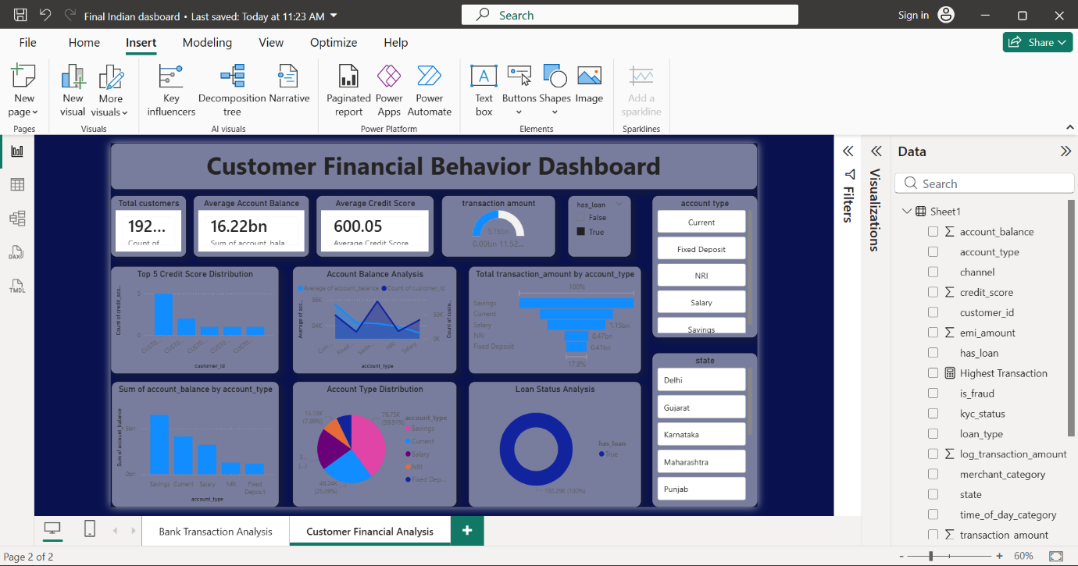
Screenshot :
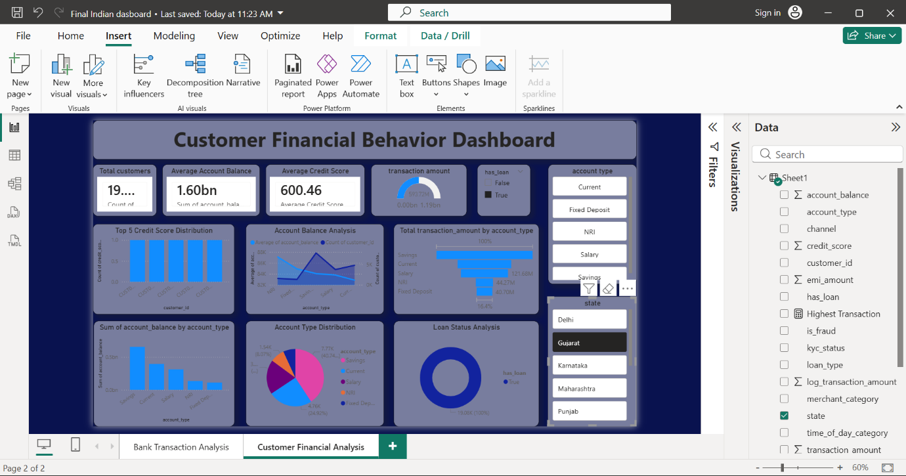

Screenshot :
